MiSTer Manual

Revision 0.9  
  
Guide to MiSTer computer and console cores  
  
*“Helpful instructions as to what each system’s keyboard and controllers looked like and basic instructions and commands to get use each system (and play its games)”*

The MiSTer is an FPGA (Field Programmable Gate Array) based system that can simulate various computing devices. Picking the word simulate over emulate over various other words seems to create debate, but I will not delve any further into that other than to say that the big difference between this and having an emulator in your computer is that MiSTer offers a more accurate, hardware (logic gate) based simulation of the original hardware.

The MiSTer’s base is a Terasic DE-10 Nano board and then there are several optional boards that can be added on. I think most would agree than the I/O Board is essential as is an SDRAM board, but there are several interesting others such as the real time clock, the ADC board and the MT32-Pi Hat. With MiSTer there’s lots to explore, but that isn’t the point of this guide so let’s get started.

Before jumping in it is important to know that OSD means On Screen Interface and that’s the interface that lets you control MiSTer and allow you to virtually insert disks, tapes and cartridges into your simulated device. It is also important to know that the MiSTer I/O board itself has 3 buttons:

1. Reset
2. On Screen Display (OSD)
3. Core Specific (Often used as a Core Reset button)

Useful links (and sources of some of the included info):

<https://github.com/MiSTer-devel/Main_MiSTer/wiki> - MiSTer Wiki Home Page  
<https://github.com/Grabulosaure> - MiSTer Intellivision Core (and more)  
<https://github.com/theypsilon/Update_All_MiSTer> - MiSTer Update scripts (highly recommended)

Credits (aka some helpful info contained within also came from):

<https://pastebin.com/pM1XMe5E>

Computers

|  |  |
| --- | --- |
| Acorn Archimedes  Acorn Atom  Altair 8800  Amiga (Commodore) Amstrad CPC6128 Amstrad PCW  Apple IIe  Apple Macintosh Plus  Atari 8-bit (800/XL/XE)  Atari ST Acorn BBC Micro / Master 128k  Commodore 16 and Plus/4  Commodore 64  Commodore PET  Commodore VIC-20  Jupiter ACE  Mattel Aquarius  MSX Orao  Oric-1 / Oric Atmos (Tangerine)  IBM PC 486DX33 (AO486)  PDP-11  SAM Coupe  Sinclair ZX Spectrum  Sinclair ZX81  TI-99/4a (Texas Instruments)  TRS-80 Color Computer 2 TRS-80 MC-10  TRS-80 Model I  X68000  ZX Spectrum Next |  |

Acorn Archimedes (Archie)  
  
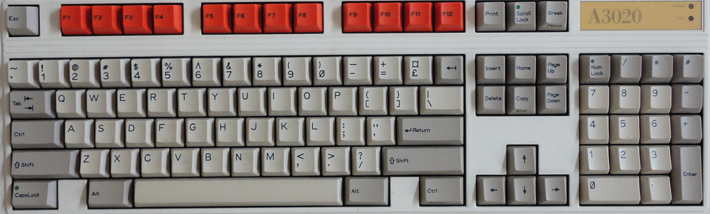

Win+F12 - OSD  
Alt+Win+F12 - Reload Core  
  
Loading Programs  
  
Core boots to RISC OS GUI  
Use OSD to insert a floppy disk image  
Click on Drive 0 (bottom left) and a window will open with the disk’s contents  
Double-click on program icon to load

Acorn Atom

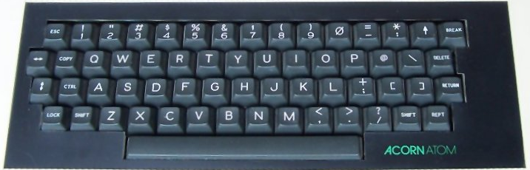

Supports 32KB of memory

Caps Key = Shift Lock  
Alt-Right = Repeat  
Alt-Left = Extra Shift Key  
Tab = Copy  
Up-Arrow = Shift+6 (so to ‘Shift’ this you would need to use the Alt-Left key as well)  
Break = F10

Shift-Break (F10) to mount the VHD  
Ctrl-Break (F10) to quit / disable the MMC ROM

This core requires a virtual hard drive file named boot.vhd formatted as a FAT volume (there is a sample in the MISTer git for the Acorn Atom core named blank.zip that you can mount and copy files to).

To prep a boot.vhd file you can mount it under Windows, copy files to it, detach and then put that file on the SD card in the games/AcornAtom folder

To use a .VHD with this core

* Select .VHD file via the OSD
* From BASIC press Shift+F10 to reboot (and boot from the .VHD)

Altair 8800

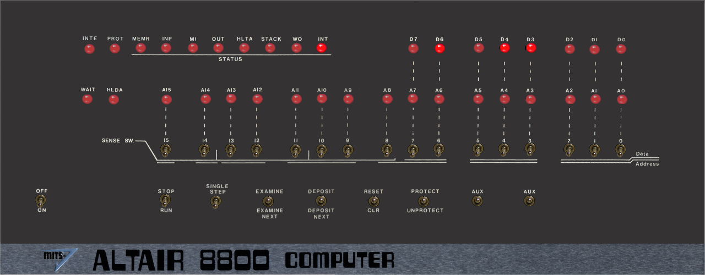

Use cursor to select switches and press 1 key (up) or 0/2 key (down)

In order to run one of the included programs (external programs are not supported):

* Select the program
* Navigate to On/Off and press 2 to flip the switch that turns the Altair 8800 on
* Ensure that Stop/Run switch is in Stop Mode
* Use OSD to select and load the program
* Navigate to Reset/CLR switch and press Reset (1)
* Navigate to Stop/Run and press Run (2)

and watch the LEDs flash.

Amiga (Commodore)

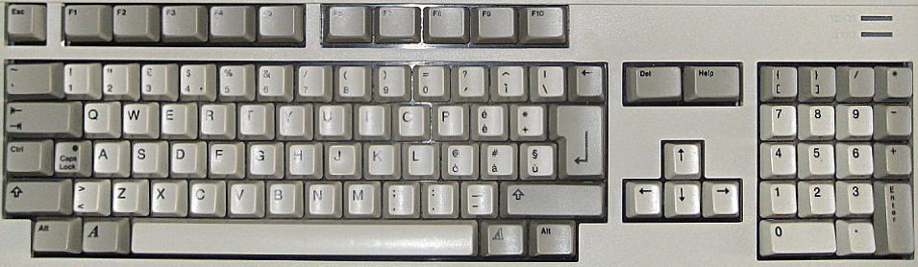

Adjust screen

Cursor keys - Top/Left  
Alt+Cursor keys - Bottom/right  
Enter - Finish and store position  
Backspace - Reset to default  
Esc - Cancel

ECS (Enhanced Chip Set) Games / Demos Settings: CPU = 68000, Turbo=NONE, Chipset=ECS, chipRAM=0.5MB, slowRAM=0.5MB, Kickstart 1.3

AGA (Advanced Graphics Architecture) Games / Demos Settings: CPU = 68020, Turbo=NONE, Chipset=AGA, chipRAM=2MB, slowRAM=0MB, fastRAM=24MB, Kickstart 3.1 For Workbench usage, you can try turning TURBO=BOTH for a little speed increase.

F11 - Start monitor

Amstrad CPC 6128

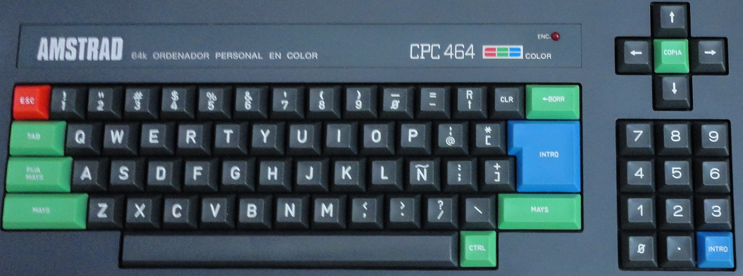

Commands (not case sensitive)  
 *Note: The pipe symbol or ‘|’ is used in many commands and is typed via Shift+@*

CAT or |DIR - List disk files  
RUN"filename - Execute a program named filename from the disk  
 (often ‘RUN"DISC.BIN’ or ‘RUN"DISC.BAS’ where including BIN or BAS are optional)  
|A or |B - Switch to drive A or drive B

Special MISTer specific core key combos:

Alt+F1 - Toggle mute on cassette sound  
Alt+F2 - Unload the tape

Loading Cassette (.CDT) files?  
 Type |TAPE to enter cassette mode when disc interface is present  
 Type RUN” (or press Shift-Enter)  
 Press any key as prompted  
  
Loading a disk with no directory/catalog?  
 Type ‘|CPM’ to load disks with no directory  
  
Loading expansions?

Amstrad PCW

Boots to a white screen? Tried loading some disk images with no success??

Apple IIe

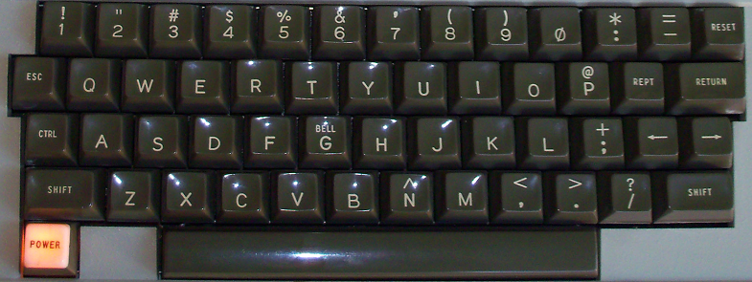

The MISTer’s Apple IIe core supports Mockingboard support, but does not yet support writing to floppy disks. Also note that the Apple II’s Reset button (upper right of the keyboard) is supported via the I/O board’s 3rd (core specific) button.  
  
Many Apple II disks are auto-boot and just require insertion via the OSD and a reset to load. However there are some games such as the Eamon series that are written in Applesoft BASIC and need further instructions to utilize:

1. You’ll need to load boot a DOS 3.3 disk which will load DOS (giving you access to DOS commands from BASIC such as CATALOG to get a disk directory).
2. Once DOS loads you’ll receive the familiar ] prompt that Applesoft BASIC uses.
3. Insert the game disk via the OSD.
4. Type “CATALOG” to see the files on it. The letters to the left of the file name such as A and B mean the following: (A=BASIC program, B=Binary (machine language) program, T=Text file).
5. Either load the BASIC program via typing “LOAD <name of program>” or “RUN <name of program”. If you load it then you’ll be able to type “LIST” and see the BASIC program code and such before you type RUN to execute the program.

Other helpful commands:

BRUN <name of program> - Runs a binary/machine language program.  
PR#6 – Boots the disk in floppy drive 1 (port 6 on the Apple II) [Note that I see a £ symbol instead of # in this core telling me it’s a British Apple II, but it appears to be serve the same purpose as the # sign)  
CALL -151 = Enter the machine language monitor

The Machine language monitor displays address/register info ala  
9BD6 – A=01 X=BA Y=54 … etc

Followed by an * prompt (which tells you that you’re in the monitor and not Applesoft BASIC)

Type ‘E000G’ to go to address E000 (and return to Applesoft BASIC [with or without DOS loaded])  
Ctrl-C followed by <Return> exits back to BASIC leaving any BASIC programs intact  
Ctrl-B followed by <Return> exits back to BASIC but clears program memory

Apple Macintosh Plus

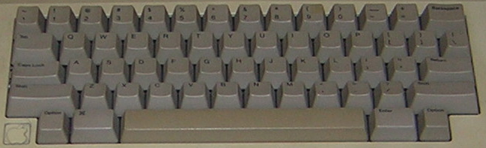

The Macintosh floppy disk drives were different as one could not just eject a floppy disk with an eject button as on a PC, but instead had to choose to eject the disk from the GUI interface. Mac OS would keep track of disks that had been in the drive and, when accessed, ask the use to reinsert said disk. Also when inserting a disk it may take several seconds for the Mac to mount the disk and for its icon to appear.

Once your disk has mounted in the GUI and its disk icon appears it should be easy to open the disk and double-click to run a program.

Alt key - Macintosh Command key (to the left of the space bar)  
Windows key - Macintosh Option key

Atari 800 /XL/XE (8-bit)

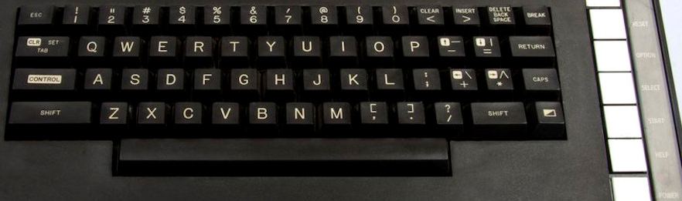

Shift+Control+N/H - Disable/Enable high speed SIO (aka speed up disk I/O)

On the right side of the Atari XL keyboard (above) are 5 keys: Help, Start, Select Option and Reset. Help was never really used as it wasn’t available on the Atari 400/800 and disappeared with the XE computers. The other keys can be accessed via a PC keyboard as follows:

F6 – Start  
F7 - Select  
F8 - Option (hold down on boot when in XL/XE mode to disable BASIC ROM)  
F9 – Reset (Warm Start)  
F10 - Cold Start (aka power cycle)  
  
Load .ATR/.ATX/.XEX/.XFD disk image (supports .ZIP files):  
  
Insert disk image via OSD  
Press and hold F8 (the Option key to disable BASIC on XL OS unless BASIC is required) while pressing F10 (Cold start) to simulate turning the computer on with the Option button being held down (optionally you can also choose XL without BASIC from the OSD, but as an old Atari owner holding down Option feels more authentic ☺.  
  
Load .CAR/.ROM/.BIN ROM cartridge image

Note: In the OSD one can select between OS A, OS B, and the XL OS. Usually you’ll want the XL OS, but there may be some older games that used undocumented OS calls that require OS B (or OS A although that’s quite rare). There was a translator disk for XL/XE computers to address this issue, but no need for that with MISTer.

Atari ST

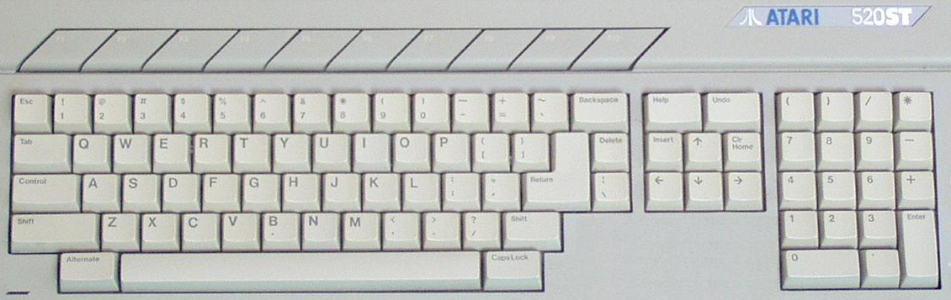

This is quite a full featured Atari ST core supporting many different configurations of the Atari ST computer. It supports two floppy drives and ACSI (Atari Computer Systems Interface) [Note: Similar, but not compatible with SCSI] hard drives as well.

Ensure there’s a version of TOS selected and the core will boot into the Atari ST’s GEM user interface.

Many floppy disks will have a folder named AUTO and it contains programs that will automatically run upon booting from said disk so you can either insert the virtual floppy disk and reboot or insert the disk after booting, double click on the appropriate floppy disk icon and run whatever is in the AUTO folder. Files with an extension of .PRG and .TOS are executables that can be double-clicked on to run them.

The Atari ST had two 9-pin ‘joystick’ ports, but the first was usually occupied by the mouse so the second was left for a standard Atari joystick.

The Atari ST supported 3 video modes: low, medium and high and they made two monitors available: one for low/medium (color) mode and one for high (monochrome) mode. If you’re just interested in playing games then it’s pretty safe to stick with the low resolution, color mode. You can change mode from the GEM Options menu.

Hard disk image files need to have a .VHD file extension in order to mount them as hard drives.

You can simulate a 1040ST (basic, early, 1 megabyte Atari ST model) with the following OSD settings:

1 MB RAM, TOS 1.02, the ST chipset, Blitter off and Viking (not sure what this is?) off.

You’re probably pretty safe with that for most games although enabling the blitter probably wouldn’t hurt.

You can simulate a Mega 4 STe (later enhanced model with 4 MB RAM) with the following OSD settings:

4 MB RAM, TOS 2.06, the STe chipset, Blitter on and Viking off (the Mega STe also allowed the 68ks clock speed to be toggled between 8 MHz (better compatibility) and 16 MHz.

Acorn BBC Micro / Master 128k

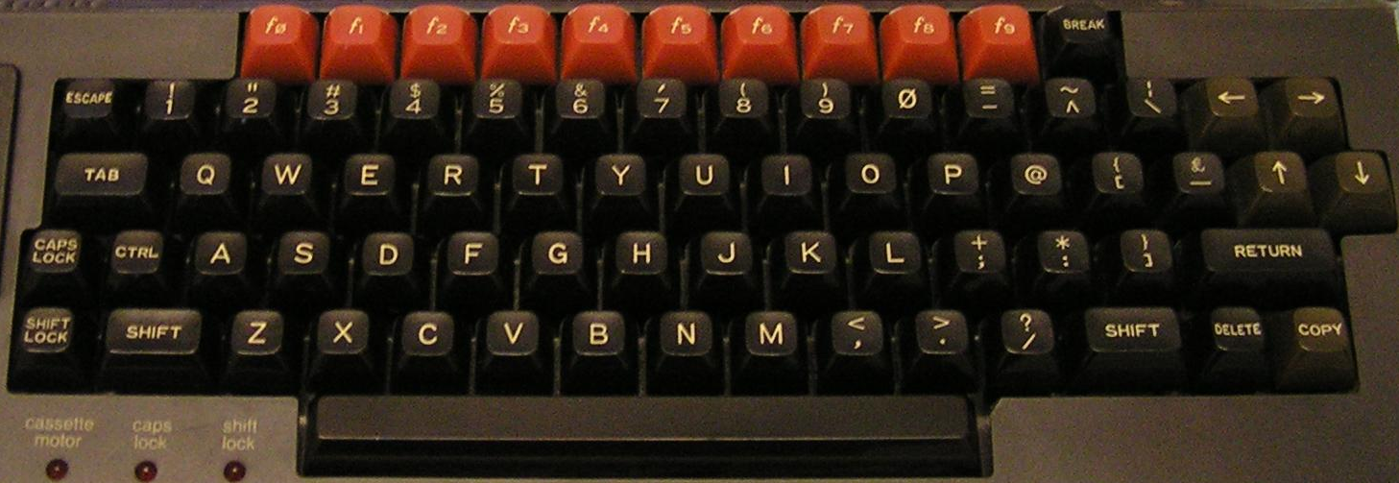

Ctrl+F11 - Break key  
Shift+Ctrl+F11 - Reset (with autostart if autostart is disabled)  
  
Software is loaded via MMB files which are essentially VHDs. Stick a file names BEEB.MMB on your SD card and it’ll boot (often with a menu of programs?). You can create your own MMB files, but it’s not hard to find precreated ones that are quite comprehensive.  
  
From BASIC  
  
*. or *CAT - Show a disk directory  
*DRIVE X - Switch default drive to Drive X (X = 0-3)  
*DIN XXX - Select Disk XXX (XXX = 0-510)  
  
Only the SD cards in the secondary slot support writing  
Some games (Uridium) only work on VGA (not HDMI) (bug?)  
  
How to boot to BASIC (to enter the above commands)?

Commodore 16 and Plus/4

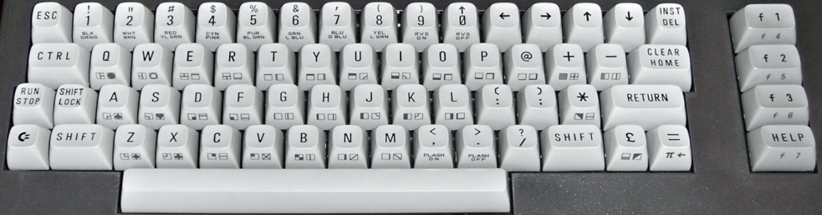

The Commodore 16 core will boot to BASIC. It did have two joystick ports, but they were not the standard DB-9 (Atari style) ports however they were pin compatible so there are adapters (i.e. the joysticks were of the one button variety).  
  
Supports PRG/D64/TAP files (BIN carts on Plus/4?)

.PRG files (.PRG files are directly injected into memory)

* Load .PRG file via the OSD
* Type RUN from BASIC

.TAP files (cassette tapes)

* From BASIC type LOAD
* Select .TAP file from the OSD
* Initially the .TAP will be searched for a program, when found there might be a small delay, but it will resume loading shortly thereafter
* You may need to type RUN once loading completes

.D64 (disk image files)

* Select the .D64 file from the OSD
* Type LOAD “*”,8,1 (Shift+2 = “ and ] = * on a PC keyboard)
* You may need to type RUN once the program has loaded

.BIN carts on Plus/4 (untested)

* Load .BIN file via OSD
* Press F2 from BASIC

Commodore 64

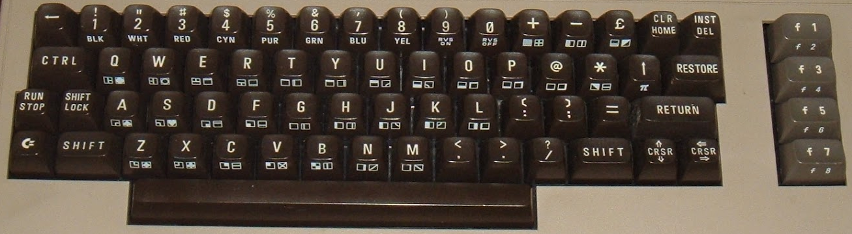

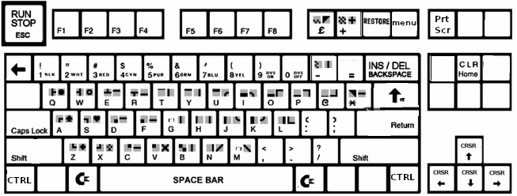

Keyboard Mapping  
  
F2/F4/F6/F8/Left/Up - Automatically activates the shift key (just as on a real C64 to use these keys)  
F9 - Pound Key  
F10 - + key  
F11 - RESTORE key  
Alt - Commodore Key

Insert a virtual disk (.D64 file) via the OSD and type the command (Shift-2 is the quotation mark on a C64 keyboard) to load it from device 8 (the first disk drive)

LOAD "$",8

followed by

LIST

to see the directory of files on the disk. Loading a binary game (PRG file) from disk is done via typing

LOAD "NAME",8,1

(or leave the “,1” off for a BASIC program) followed by

RUN

Commodore PET

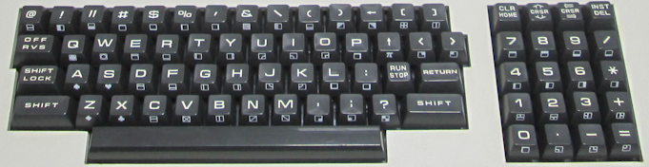

.PRG files - These are injected directly into memory. Select/load via OSD and type RUN from BASIC.  
.TAP files - Select from the OSD and press F1 to load.

Commodore VIC-20

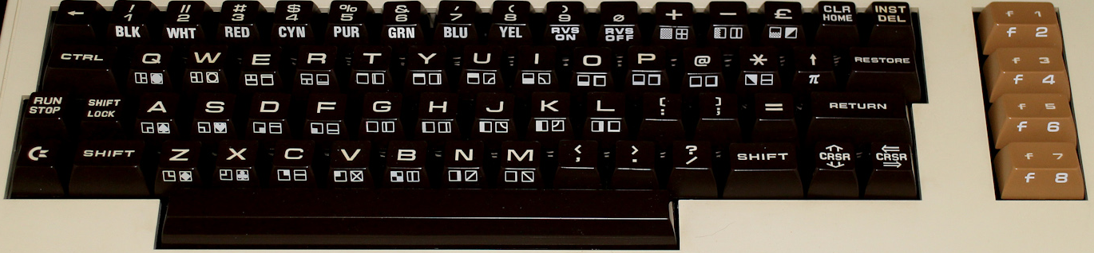

The VIC-20 is a bit of a pain due to it not being as simple as ensuring maximum memory and loading any program. As memory of various sizes was added it would shift things around in the VIC-20’s memory map. This translates to sometimes having to get just the right memory configuration to load a given piece of software. It would be great if there was a chart containing this info, but I have yet to find one.

In order to get this core to work you will need a very specific boot.rom file that contains the C-1541 ROM, VIC-20 PAL ROM and VIC-20 NTSC ROM appended together into a single 32KB file. With that the VIC-20 would, like most computers from the early 80s, boot into BASIC.

Left Ctrl+Left Alt+Right Alt will reboot the VIC-20.

.PRG files (program files that will just be directly injected into memory)

* Select/load via OSD
* Type RUN from BASIC to execute

.TAP files (cassette tapes)

* From BASIC type LOAD
* Select the .TAP file to load from the OSD

.DSK files (disk images)

* Select .DSK file from the OSD
* From BASIC type LOAD “*”,8,1

.CRT/CTx files (cartridges)

.CRT files have a header indicating where in memory to load them. CTx files do not and replace the letter x in the filename with a hexadecimal 2-B indicating at what memory address to load them. Many ROM image files will have an extension of a0 or 60 or something like that and it won’t be possible to tell if it has a header or not. To determine that look at the file size in bytes. If it’s a power of 2 (e.g. 4096, 8192, 16384) then it does not have a header and you can replace the x in the filename with the file letter of the extension (e.g. .a0 becomes .CTa) and if it’s a power of 2 plus 2 bytes (e.g. 4098, 8194, 16386) then it has the 2 byte memory address header.

* Load these files via the OSD. There maybe be more than one for a single game… if so load them all.
* From BASIC type SYS <memory address> to run the game (or Ctrl+F11 to run at address $A000 which seems to be a common starting address hence the Ctrl+F11 shortcut for typing SYS 40960)

Jupiter ACE

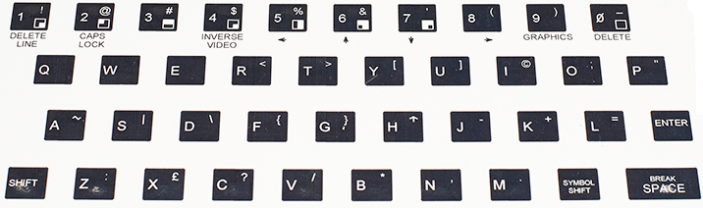

Just select/load an .ACE file from the OSD and it automatically runs

Mattel Aquarius  
  
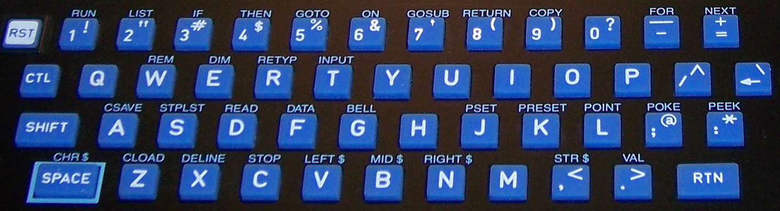  
  
Keyboard cursor (direction) and F1-F6 keys (buttons 1-6) are mapped to the game controller  
Tab - Toggle between Joystick 1 and 2  
  
Load cartridges (.BIN) via OSD. They automatically start after being selected.  
  
Loads .CAQ files (most require 16k RAM extension)  
  
CAQ files are usually distributed in pairs. The first part is a BASIC loader and the second part is the machine language portion. To load these:  
  
Type CLOAD  
Insert the first part of the tape via the OSD  
Wait for it to load  
Type RUN and you should be prompted to insert the cassette and hit Enter  
Insert the second part of the tape via the OSD  
  
CLOAD ”<optional name>” – Load cassette program. If a name is given then it will search for that program otherwise it will load the first program it finds (as above).  
  
Notes: The Aquarius used keyboard and controller overlays for its various software titles.

MSX

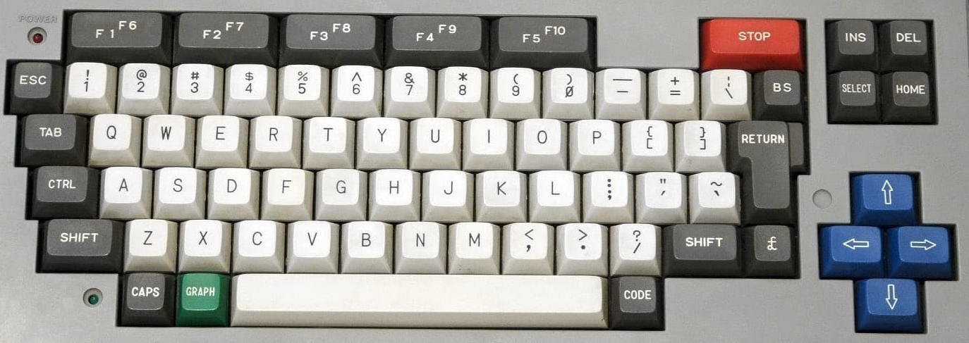

The MSX is interesting as it’s kind of like a PC in that many companies made them based upon a standardized architecture (as provided by Microsoft and ASCII Corp). It also evolved into an MSX 2 and eventually an MSX 2+ (and MSX 3) and this core supports them all. The MSX used ROM cartridges, tapes and floppy disk media for program storage. This system was a major player in Japan and has some great game titles on it and a rich history. There’s much to explore here.

Press F11 to change CPU speed when in Turbo mode  
Core recognizes short (warm) / long (cold) [hold 2+ seconds] reset button (the core specific button on the MISTer itself)

Has a file manager (MM) to allow for loading ROM and DSK files as part of SDCREATE package that is available alongside the latest core which is used to create a secondary SD card that will go into the I/O board’s SD card slot along with a menu program (SofaRun seems popular) to load them, but I have yet to try that.  
  
Virtual Hard Drive support definitely works though and if you can find an existing .VHD image to boot from then that offers a quick and easy way to start enjoying this core.

Orao

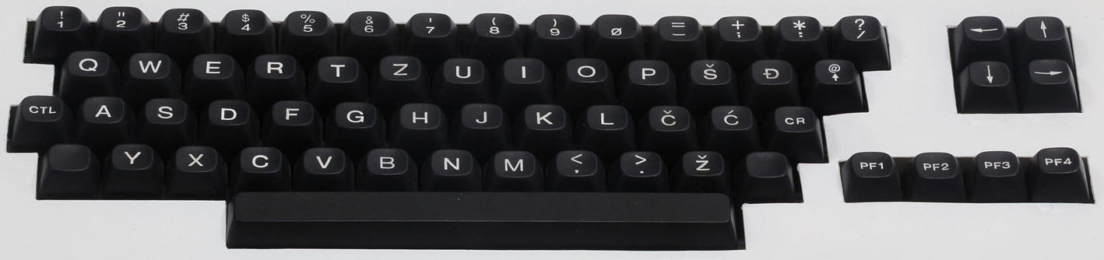

The Orao core supports only cassette tape based software.

Oric-1 and Oric Atmos (Tangerine)  
  
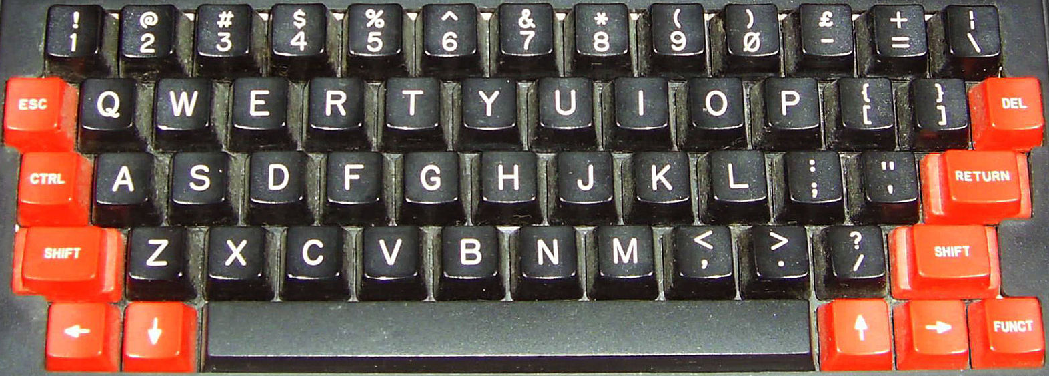  
Oric Atmos keyboard  
  
Special keyboard keys for this core:

F10 – NMI key  
F11 – Reset (use to reboot after a .DSK image is selected via the OSD)

.DSK files (disk images)

* Select bootable .DSK file from the OSD
* From BASIC press F11 to reboot and load the bootable disk

Note: Some disks are displaying an “insert system disk” message which I’ll take to mean that I need to insert a disk with some sort of Disk Operating System and then load desired disk, but I have not figured that part out yet.

PC 486DX33 (AO486 core)

Win+F12 = OSD (as F12 key is the PC’s F12 key)

Simulates a 486 DX 33 MHz PC with SVGA, SoundBlaster 16/Pro, MIDI, CD-ROM and Hard Disk (via .VHD files) support. As PC keyboards are pretty standard and I’d guess many use one with their MISTer I have not included a picture of one.

PCs from around 1990 usually had a hard drive and one would install games to it from 3.5” and 5.25” floppies. Start by creating a Virtual Hard Drive (.VHD) file (You can use the Windows 10 Disk Management Utility to do this) and install MS-DOS 6.22 onto it. You’ll need the MS-DOS 6.22 3 disk .IMG file set and you’ll need to start by ensuring the floppy drive boots first, the virtual hard disk is mounted, and MS-DOS 6.22 disk 1 is in the floppy drive. Upon booting the MS-DOS 6.22 install program should load and allow you to format your virtual hard disk and install/configure MS-DOS 6.22. From there you’ll need disk IMG files to install.

PDP-11 (DEC)  
  
Upon booting this core the game Spacewar! is automatically loaded.  
  
F1 - Power on/off  
F2 - Toggle active switch row on the console view. This positions the cursor on the first switch in the row. Move left-right with numeric keyboard arrows and toggle switch with enter.  
F3 - Single instruction switch toggle  
F4 - Cycle between CRT output, Console output and Teletype.  
F5 – Start  
F6 – Stop  
F7 – Continue  
F8 – Examine  
F9 – Deposit  
F10 - Enable read-in mode  
F11 - Tape feed  
  
Loading a .RIM program file:  
  
Press F10 to enable read-in mode (or select Enable RIM mode in the OSD)  
Use OSD to select .RIM file

SAM Coupé  
  
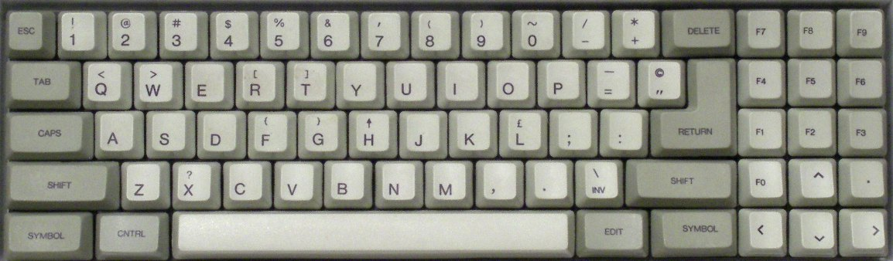  
  
F11 - NMI key  
Ctrl+F11 - Reset  
Alt+F11 - Reset and unload disk images  
  
Loading a .DSK image is done via the OSD and then it will auto boot

Sinclair ZX Spectrum

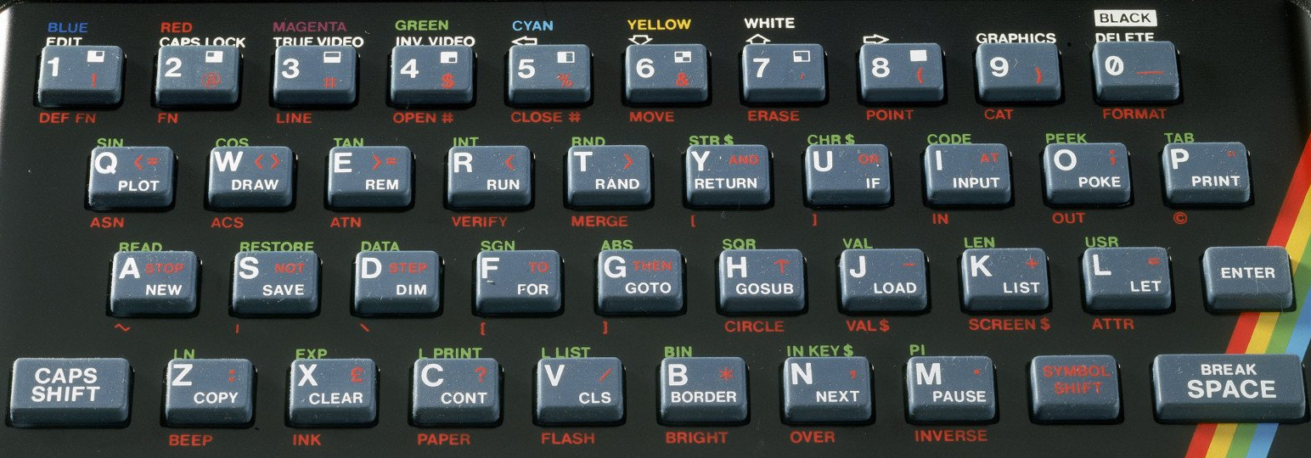

Depending on the model of Spectrum you are using you may see a menu with options like Tape Loader, 48 BASIC and/or TR-DOS or you might just see a plain © 1982 Sinclair Research Ltd on a bare bones, Spectrum with 48k.Select 48 BASIC or just press Enter to get to BASIC.

From BASIC

The cursor will show a K initially indicating that a keyword is expected. If you were to press P, for example, the PRINT statement would be auto-typed (note that that is on the P key). The cursor will then change to an L indicating it is expecting a (lowercase) letter. The character in the cursor tells you how the next BASIC command will be interpreted.

Type LOAD “” (J Symnbol-Shift-P Symbol-Shift-P) to load a tape based game. Once it loads you may also need to type RUN to run the program.

Loading .TAP/.CSW/.TZX tapes

Select file from the OSD  
Choose the Tape Loader

F1 – pause/continue loading  
F2 – Jump to previous part of tape  
F3 – Skip to next part of tape  
F4-F8 – toggle CPU speed between 3.5/7/14/28/46 MHz  
F9 – Pause/resume  
F10 – Switch to 48k BASIC and automatically LOAD “”  
Right Shift+F10 – Same as F10 with 48k lock  
F11 – Enter +D (?) snapshot menu

3 – Screenshot  
 4 – 48k snapshot  
 5 – 128k snapshot

Ctrl+F11 – Reset (warm start)  
Alt+F11 – Reset (cold start)  
Ctrl+Alt+F11 – Reset to ROM0 menu  
Right Shift+F11 – Enter Multiface 128 menu

Alt+F1 – Alt+F6 – Choose between (F1) ZX Spectrum 48k/ (F2) Spectrum 128K/ (F3) Spectrum +3/  
 (F4) Pentagon 48k/ (F5) Pentagon 128k/ (F6) Pentagon 1024k

BASIC commands

CAT 1 – List contents of IMG/MGT snapshot

Sinclair ZX81

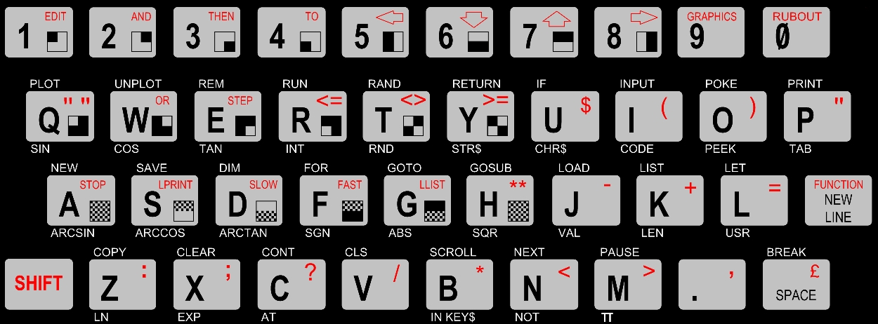

To load a game you need to insert a cassette via the OSD and type the command  
  
LOAD ""

where 'LOAD' is the J key and a double quote is Shift-P.

TI-99/4a (Texas Instruments)

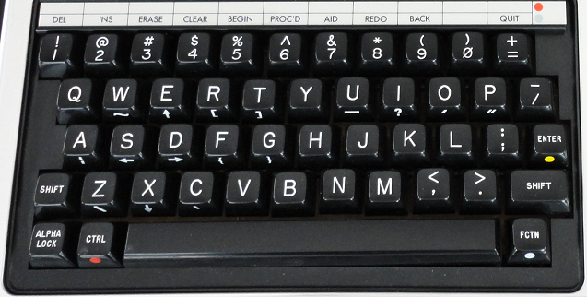

Requires the TI-99/4a BIOS as a file named FULL.BIN. Once you have that upon loading the core you can go to the OSD and load that file. The TI-99/4a will then boot. I also noticed that sound seems quite faint on this core and had to turn up the volume to hear it.  
  
The Fctn (function) key (lower right) is simulated by the Alt key on a PC keyboard and is used to access functions on the gray bar above the number keys (hence the colored dot to the right of the line and on the Fctn key). For example if you enter the TI’s BASIC then Alt-= is Quit (return to the boot menu) and Alt-3 is Erase (Backspace).

From there you can also load program ROMs from files with a *C/D/G.BIN filename. All ROM files have a BIN extension and the last letter of the filename is a C, D, or G to indicate where in memory the ROM cartridge data needs to go. Often these will be split across multiple files. You’ll need to load all of the game’s ROM files from the OSD, reboot the TI and then the game will be listed and available from the TI’s boot menu.  
  
Disks/tapes aren’t currently supported as far as I can tell, but I also dug up some disk/tape oriented commands should that day come:  
  
SAVE CS1 – Save BASIC program to cassette  
SAVE DSK1.<FILENAME> – Save BASIC program to disk as file <FILENAME>  
OLD CS1 – Load BASIC program from cassette  
OLD DSK1.<FILENAME> - Load BASIC program named <FILENAME> from disk  
CALL DIR(1) – List the content of files on disk 1 if the disk controller supports it (otherwise you’ll need to use a BASIC program or the Disk Manager ROM cartridge to view files on disk)  
  
<https://www.ninerpedia.org/wiki/TI-99/4A_system_usage>

TRS-80 Color Computer

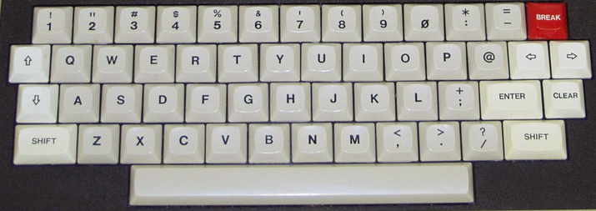

Special Keys:  
  
End – Cold start  
F9 – Run a cartridge game (aka Program Pak) after it has been inserted via the OSD  
  
After inserting a disk via the OSD you can use the following commands to see what’s on the disk and run programs from disk  
  
DRIVE # - Set the default drive to drive #  
DIR # - Disk directory of drive # where # is optional  
  
Running a BASIC program (BAS extension in the DIR):

RUN"NAME - Run the BASIC program (.BAS extension) from the disk  
  
Running a Binary program (BIN extension in the DIR):

LOADM"NAME - Load BINARY (.BIN extension) file  
EXEC - Execute the loaded binary file in memory  
  
Booting a disk that DIR doesn’t display a directory for:  
  
DOS – Command to boot an OS/9 disk

TRS-80 MC-10 (Alice)

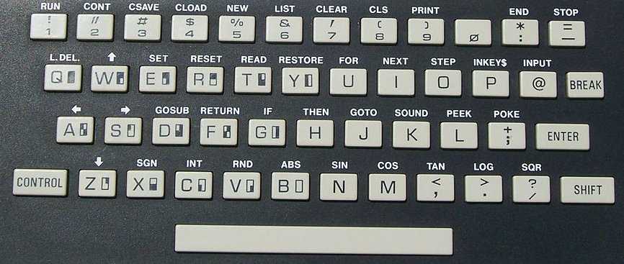

Each key has a shortcut listed above it which is accessed via the Control key. The core supports the 16k RAM expansion and cassette drive via both .C10 files and the MISTer ADC add on board (real cassettes).

How to load a Cassette game from a .C10 file:  
1) Boot into the core (Microsoft BASIC)  
2) In the OSD select the cassette game you want to load.  
3) From BASIC press Control-4 which will display the CLOAD command on screen. Press Enter.  
4) From the OSD click on ‘rewind’ and then click on the ‘play’ option.  
5) You should see a flashing S (searching) in the upper left corner that changes to an F (found) along with the name of the program that is loading.  
6) Once the game loads just type RUN.

Note: I have had minimal success with this… some games don’t seem to load properly and others just don’t run. In many cases I can type the BASIC LIST command to see what BASIC code loaded into memory and usually that looks all right although sometimes it does not. Having never owned one of these and not being sure what to expect I can’t diagnose where things are going wrong. I tried enabling/disabling the 16k memory expansion in my trials. The notes for this core indicate an existing issue with switching video modes so hopefully that’s the bulk of the issue I am experiencing.

TRS-80 Model I

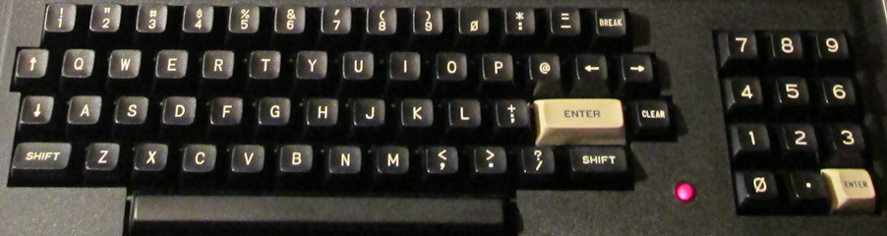  
  
The TRS-80 Model I core has grown to become quite full featured. Note that on the keyboard the Clear key (next to the white Enter key) is simulated by the PC keyboard’s Home key and Break (upper right) is the PC keyboard’s Escape key.

When booting you will either need to insert a disk with a DOS (Disk Operating System) on it OR quickly press Escape to start the system as a cassette based TRS-80. Note that many cassette games won’t work on a DOS (disk) based system.

To load a machine language cassette program:  
  
After the core boots and you quickly hit Escape you’ll see a ‘READY?’ Prompt  
Press Enter/Return and, after a second or two, you’ll see the ‘READY’ prompt shift to the bottom of the screen  
Type SYSTEM and a ‘*?’ prompt should appear  
Go to OSD to select cassette to load into cassette drive  
Type the six letter name (the first letter will suffice) of the file to load, press Enter and wait for it to load  
Type / to run the game  
  
To load a BASIC cassette program:  
  
CLOAD – Load cassette game  
RUN – After CLOADed to run loaded cassette game

In order to load disk based software you will need to boot with a DOS. The following DOS Commands will be helpful:

DIR # - Show a disk directory when # is the drive number (drives 0 and 1 are supported in this core)  
<filename of CMD file> - Load and run program (CMD files are machine language programs)  
BASIC RUN”<filename>/BAS” - Init BASIC and run BASIC program (BAS files are BASIC programs)

JV1/JV3/DMK .DSK images

JK1, JV3 and DMK a formats of .DSK image file. This core only supports JV1 format .DSK files.

X68000 (Sharp)

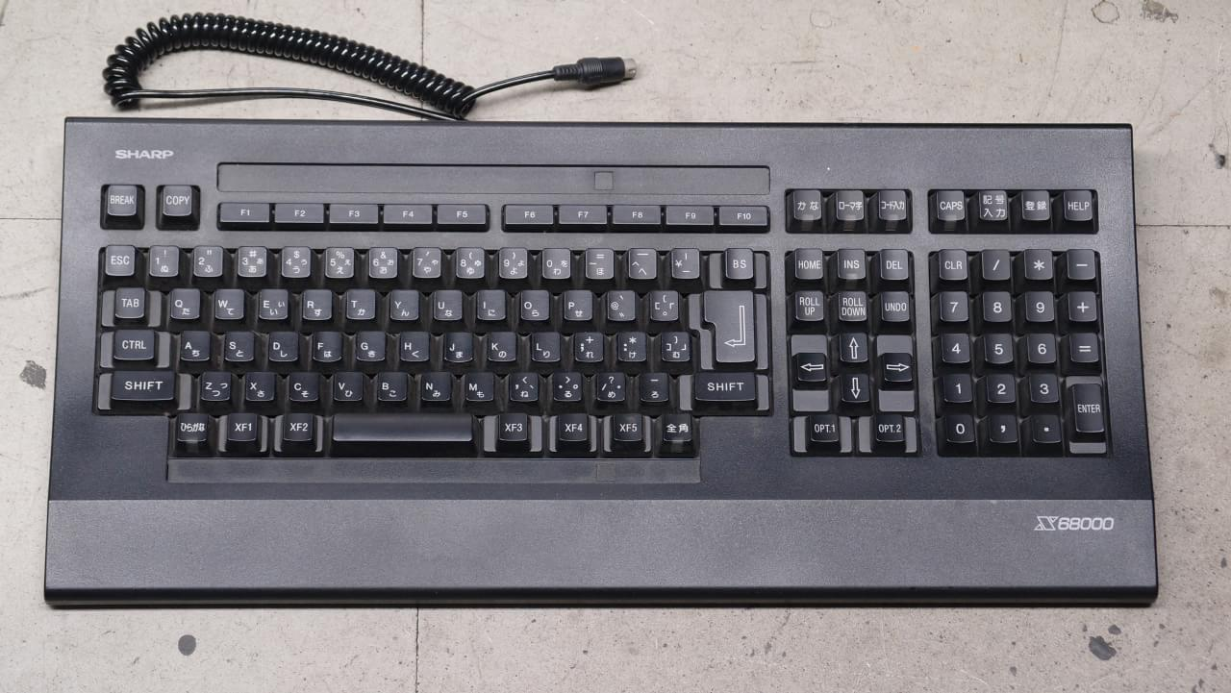  
  
Disk images (both floppy and hard disk) need to be placed on an SD card in the secondary card slot on the I/O board.

F11 – Disk Emu menu

Note: This core has not has a new ‘official’ build since 2017, but work is being done and updates are available.

ZX Spectrum Next

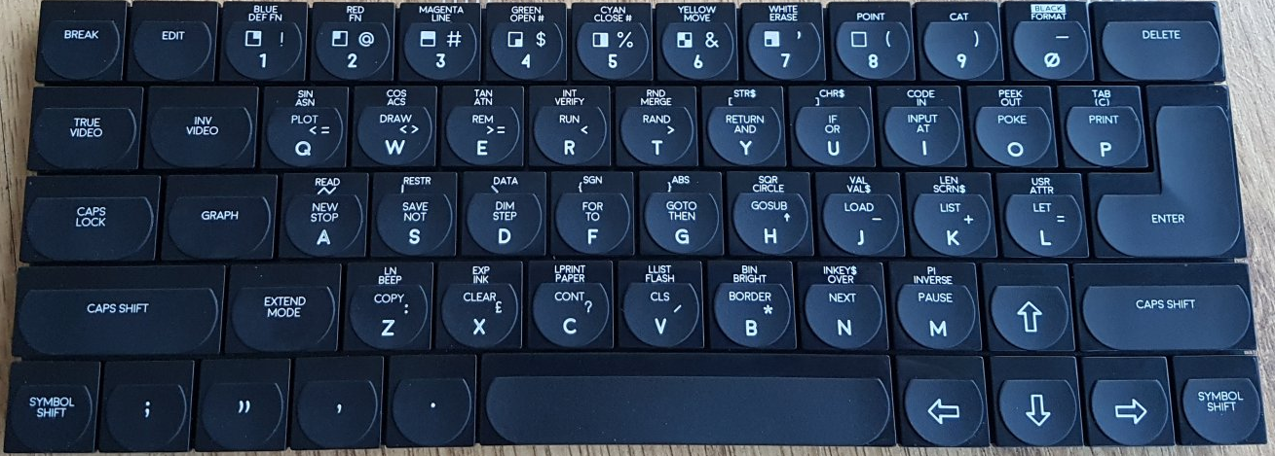

The ZX Spectrum Next is a fan made, souped up ZX Spectrum computer.

F1 – Reset  
F3 – Toggle 50/60Hz  
F8 – Change CPU Speed (3.5/7/14/28 MHz)  
F10 – DivMMC NMI  
F11 – NMI/Multiface

Consoles

|  |  |
| --- | --- |
| Astrocade Atari 2600  Atari 5200  Atari Lynx  ColecoVision  Game Boy / Game Boy Color  Game Boy Advance  Genesis / MegaDrive (Sega)  Sega Master System (SMS) / Game Gear  Sega CD / Mega-CD (Sega)  Neo Geo Advanced Entertainment System (AES)  Nintendo Entertainment System (NES)  Odyssey II (Magnavox) |  |

Astrocade

The Astrocade console had a calculator like keyboard on the console and game cartridges that have a form factor very similar to cassette tapes all the way down to the eject button on the console for them. Its controllers were certainly unique. They had a gun style fire button with a combination joystick/paddle on top that you could operate with your thumb in joystick mode.  
  
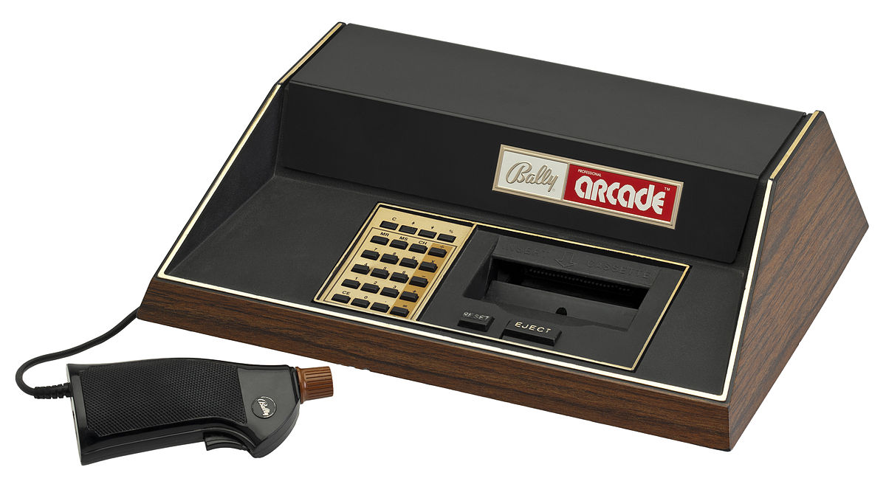  
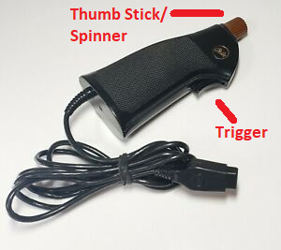

Atari 2600

The Atari 2600, while not being the first cartridge based game console, is often cited as the game console that started it all. The console itself had six switches (power, color / black & white, a left and a right A / B difficult switch, a game select switch (as games often came with many variants) and a game reset switch. I know of at least one game that used these switches as part of its controls (Star Master). The joysticks were simple with a single button and the console came bundled with a set of paddle (spinner) controls although they did have a limit as to how far they could be turned (the driving controllers were similar to the paddles, but did not have the limit). They also, later, released a couple keyboard/keypad style controllers for games like Codebreaker and Star Raiders.

Some memory mappers for cartridge games must be explicitly a part of the filename. See the MISTer Atari 2600 core for details as to which games will require this to work properly.

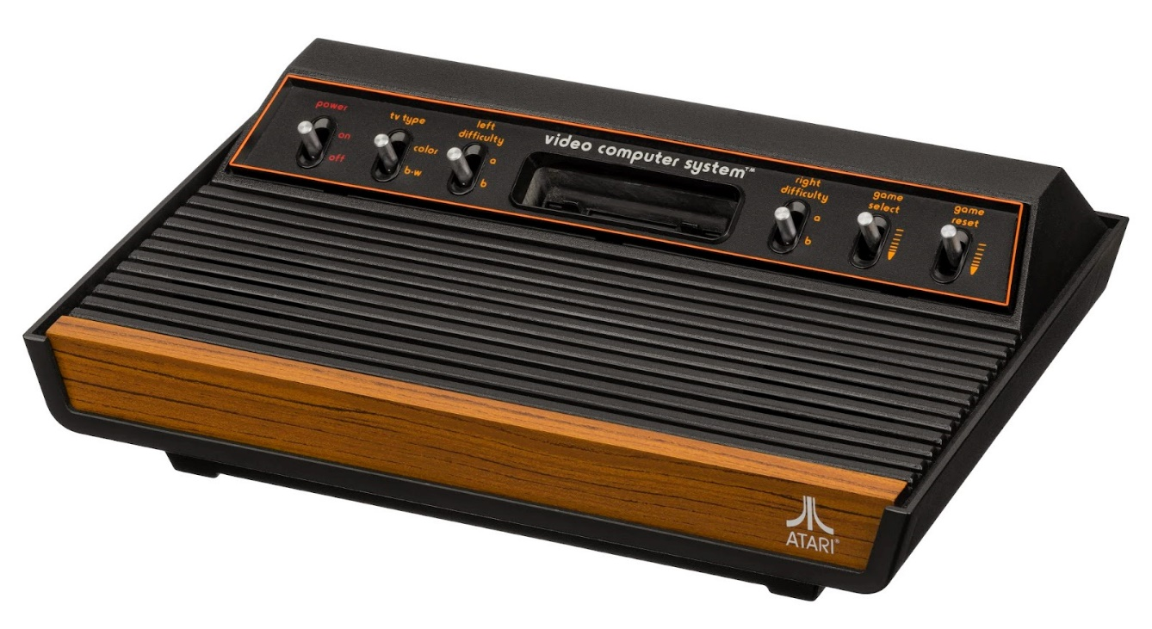

|  |  |
| --- | --- |
| See the source image | See the source image |
| Atari 4 way/1 button joystick controller | Atari paddle/spinner with 1 button |

Atari 5200

This is the same core as the Atari 800XL core as the two systems had almost identical hardware. The biggest difference may have been the controllers: the Atari 8-bit computers had a keyboard and traditional one button joysticks/paddles, but the Atari 5200 had an analog joystick with 2 buttons at the top of each side, Start/Pause/Reset buttons along the top, and a 12 key keypad with the digits 0-9 * and #.

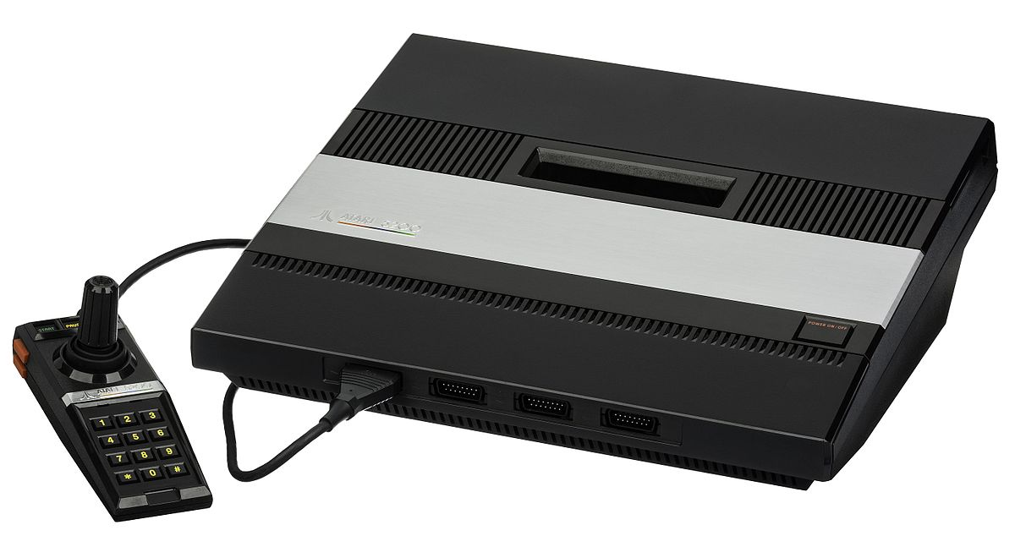

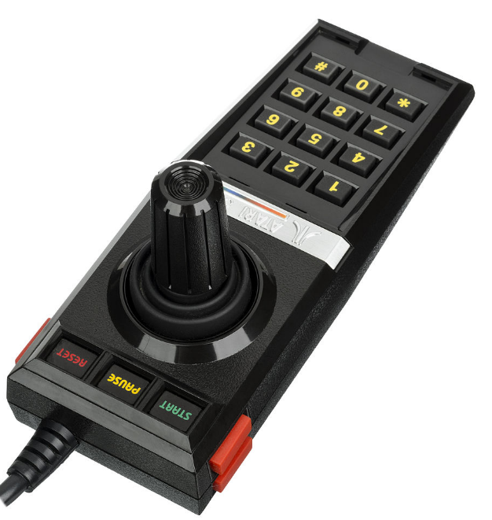

Atari Lynx

The Atari Lynx was Atari’s technically superior, portable Game Boy competitor featuring color graphics and advanced scaling hardware to provide. It also consumed batteries very quickly making an AC adaptor an important add-on. The console features a DPad and a two buttons labelled A and B for game playing. It had two of each button so left handed users could flip the console over and play in comfort. Additionally it had two option buttons, a restart button and a flip button (for the aforementioned feature).

The core provides 4 game save states access via F1-F4 to load and Alt+F1-F4 to save.

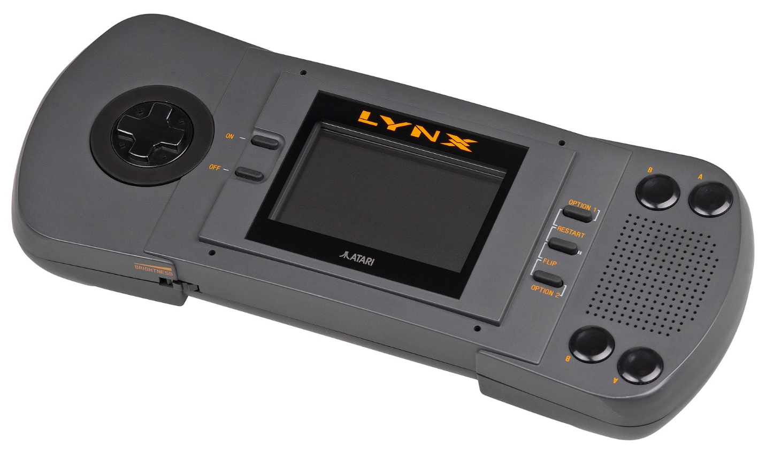

ColecoVision (and Sega SG-1000)

The ColecoVision was every 1982 arcade aficionado’s dream come true boasting (and delivering) an ‘arcade at home’ experience and including the immensely popular Donkey Kong as a pack in game. Its controllers were geared at being held by one hand that could squeeze the two buttons on the left/right side of the joystick along with a 12 key keypad. Some games would include overlays for this keypad (much like on the Intellivision). The system also offered an expansion slot on the front right that supported an Atari 2600 adapter, a roller controller (track ball) and a driving controller (for games like Turbo). An advanced joystick type controller was also later released called the Super Action Controller.

This core supports .COL/.BIN/.ROM game cartridge ROM files.

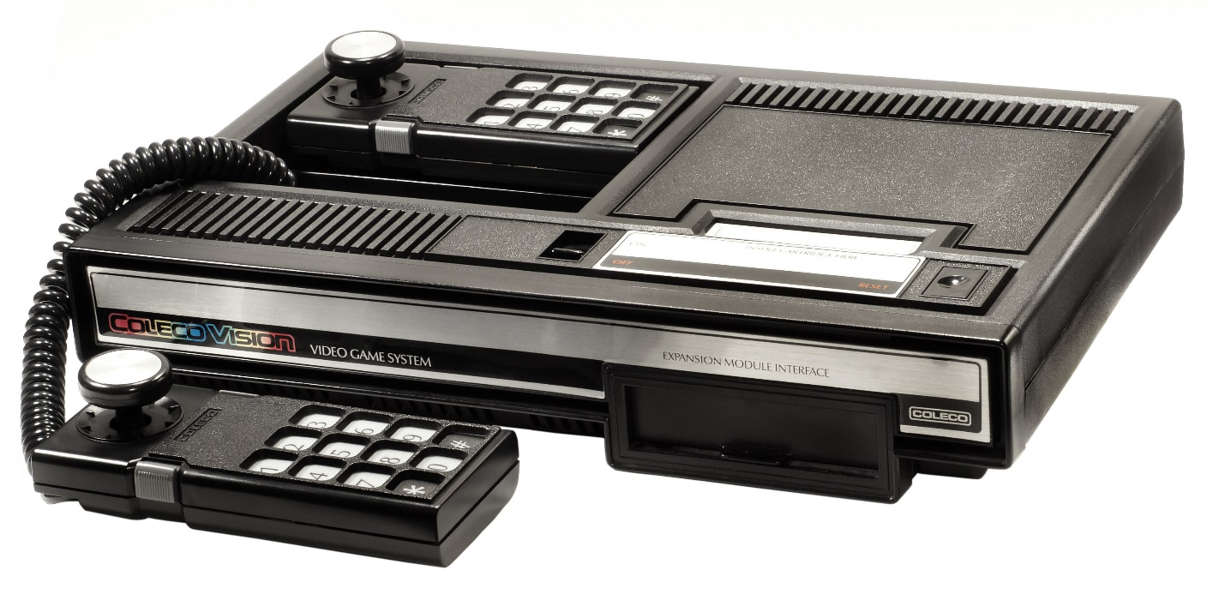

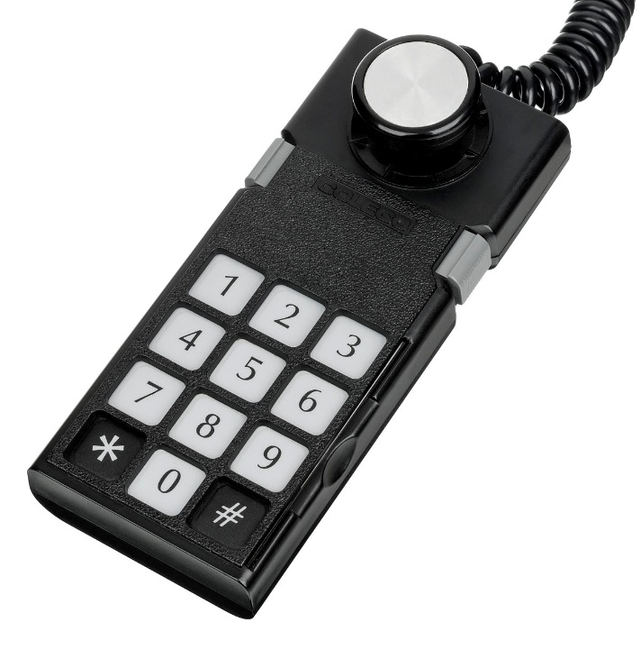

Game Boy/Game Boy Color (Nintendo)

The Game Boy was Nintendo’s first portable game console and features a monochrome screen and was initially bundled with the smash hit Tetris game cartridge.

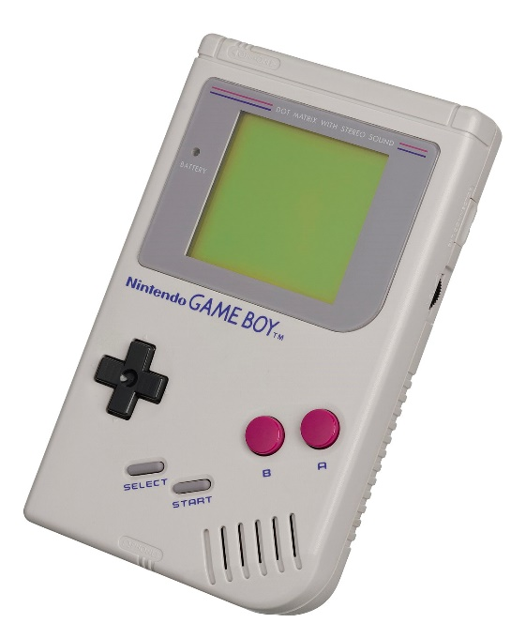

Game Boy Advance

The Game Boy Advance was the next step in the evolution of the Game Boy line of hand held game consoles from Nintendo. It sported the same basic controls as the original with A/B buttons, a DPad and Start/Select buttons.

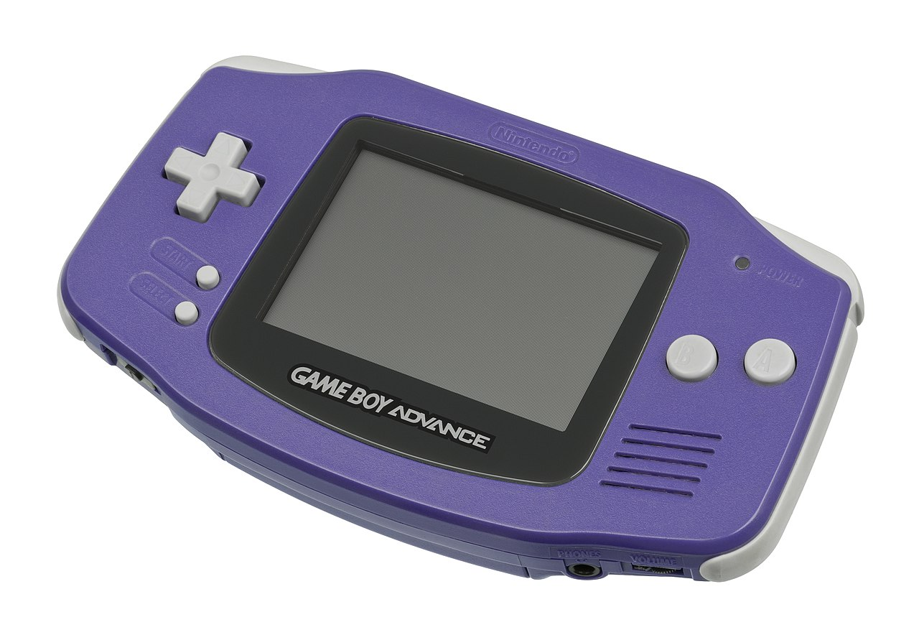

Genesis / MegaDrive (Sega)

F1 – Reset as Japanese NTSC Console  
F2 – Reset as North American NTSC Console  
F3 – Reset as European PAL Console

The header on the ROM cartridge images files may be used to detect the region of the cartridge, but you can always force a particular region with extensions of .BIN for Japanese, .GEN for North American, and .MD for European game cartridges.

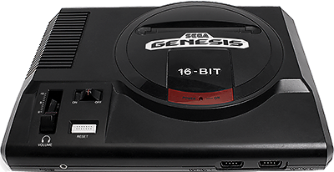

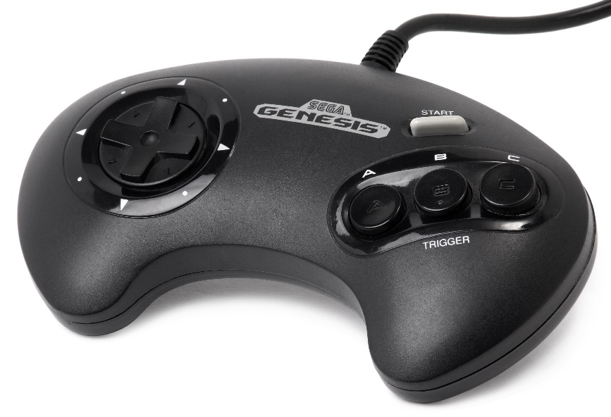

Intellivison (Mattel)

The Intellivision was Atari’s big competitor in the early days of the Atari 2600 boasting more realistic looking sports games and a controller with much more functionality and a strange disc based joystick substitute. The controller had a 12 button numeric keypad that supported overlays that each game typically included, 4 buttons on its sides and a multi-directional disc that one would press on in place of a more standard joystick (there were add-ons that one might attach on top of this to give a more joystick like feel).

Ensure that you create a directory named ‘Intellivision’ in the root of your SD cart and include files with a ROM or INT file extension. ZIP files are supported.

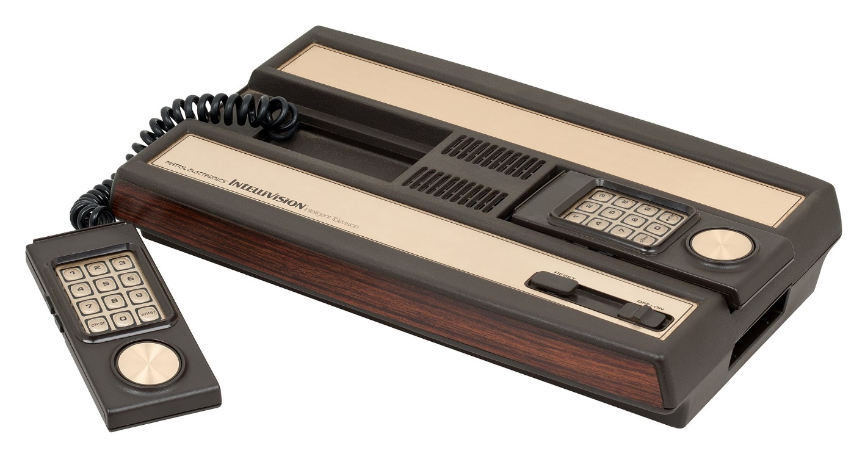

Sega Master System (SMS) / Game Gear

The Sega Master System was Sega’s answer to Nintendo’s NES, but while realizing success in Europe it failed to gain any real traction in the USA. It supported both typical cartridges (top slot) as well as game card resembling would the TurboGrafx-16 would later use (front to the right of the controller ports). The game controllers were a simple D-Pad with two buttons labelled 1 (Start) and 2. It was released with a light gun just like the NES. Later they released a joystick version of the game pad controller and also a ‘sports pad’ which was just a track ball and eventually 3-D Glasses. The Game Gear is really, more or less, a portable Sega Master System albeit using a different form factor for the game cartridges making them not directly compatible although there was a converter for playing SMS games on the Game Gear.

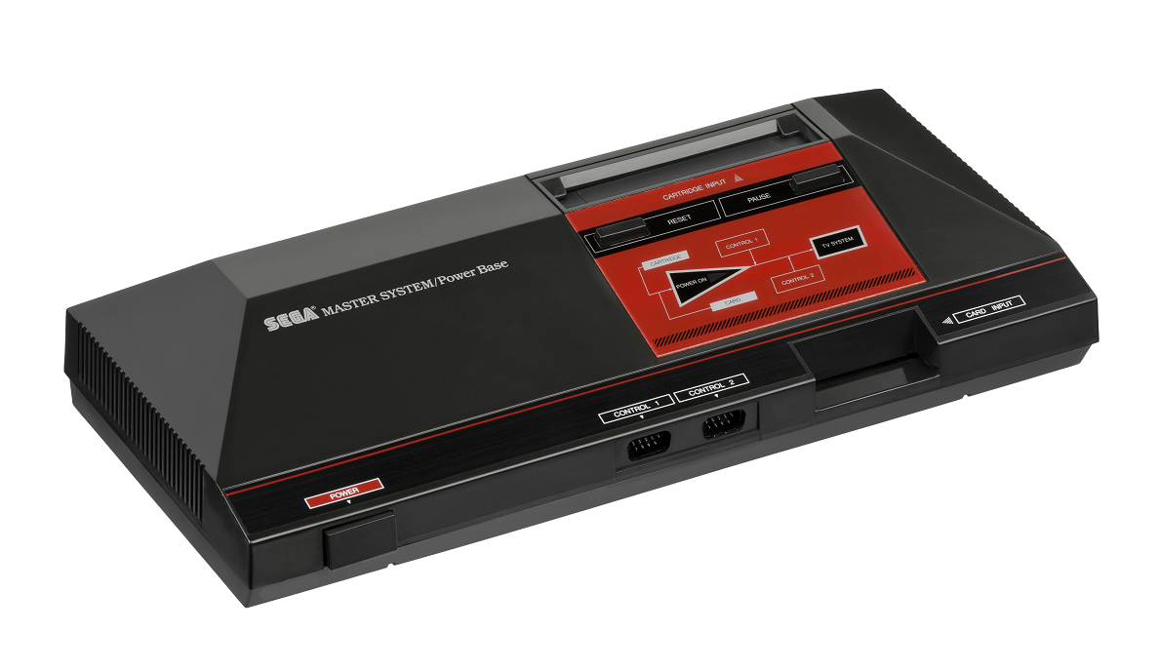

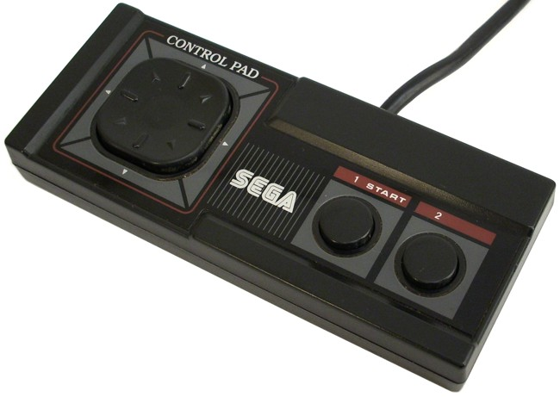

Sega CD / Mega-CD (Sega)

The Mega CD is actually a CD-ROM add-on for the Sega Genesis and is not a stand-alone console, but had its own CPU. It would attach via an edge card connector on the right side of the Genesis hardware. It brought the world of full motion video (FMV) to Sega Genesis games. Requires CD_BIOS.ROM in the game folder.

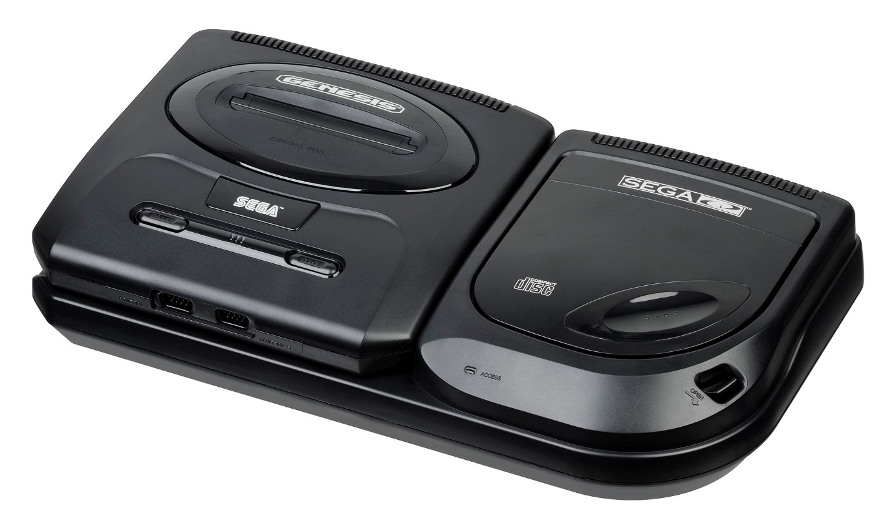

Neo Geo Advanced Entertainment System (AES)

The Neo Geo AES is SNK’s home console version of their stand up MVS arcade game system and later added a CD-ROM attachment. The controllers were sturdy, arcade like controls with a ball top joystick, Start /Select buttons and 4 buttons labelled A, B, C and D for game play. The sheer size of the game cartridges really set this system apart as did its price.

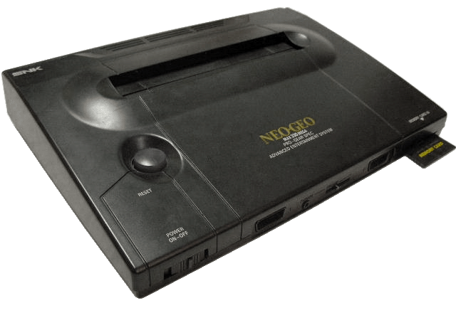

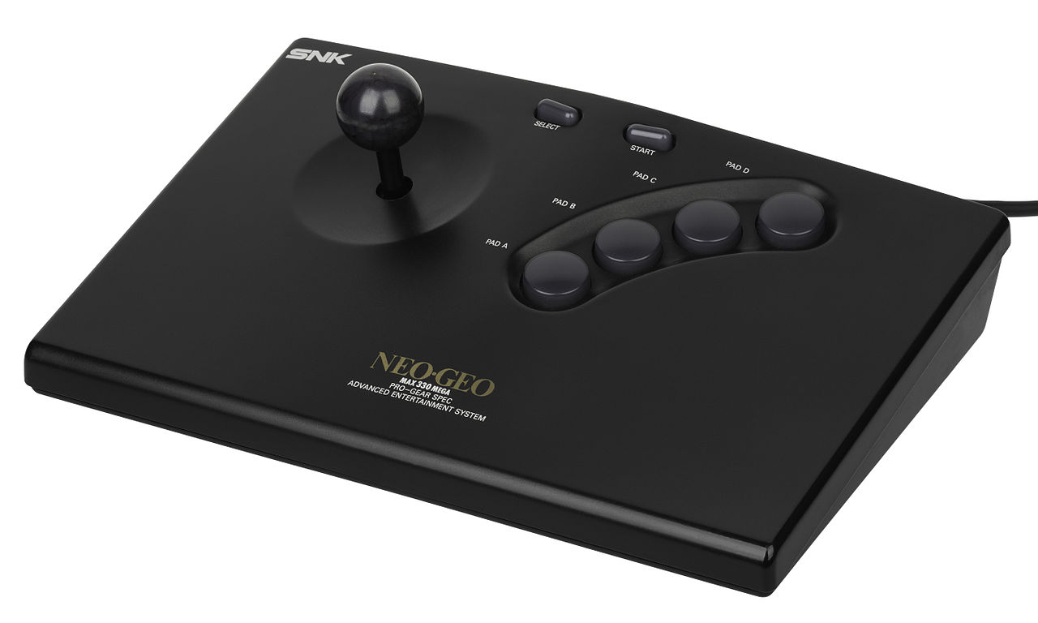

Nintendo Entertainment System / NES (Nintendo)

The NES was Nintendo’s blockbuster game console release following 1983’s famous video game crash. The NES core also supports the Famicom Disk System. Its controllers offer Start / Select buttons alongside a D-Pad and two buttons for gaming labelled A and B.

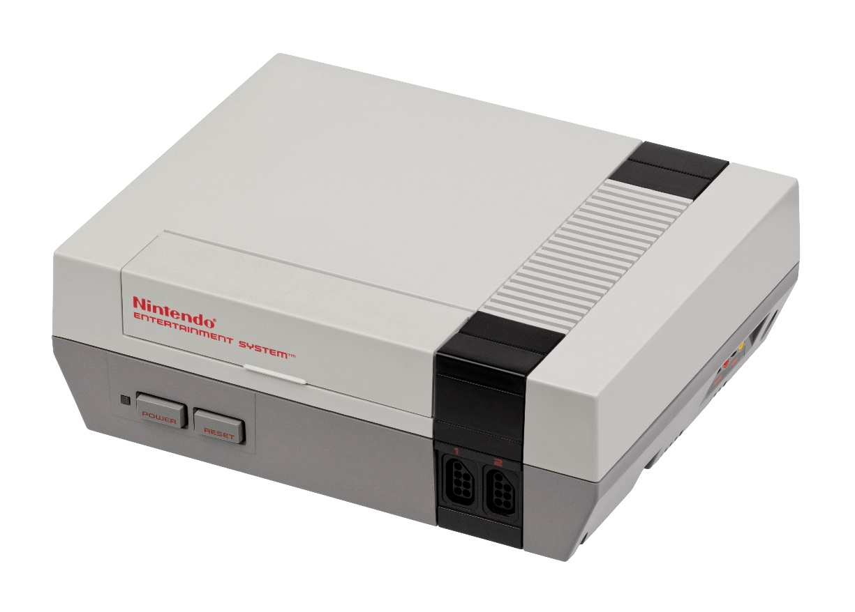

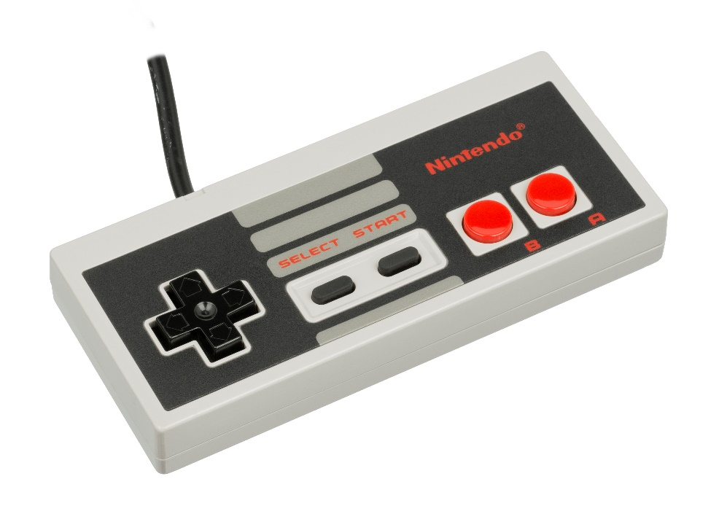

Odyssey II (Magnavox)

The Odyssey II had self-centering one button analog joystick controllers and the console had a membrane keyboard allowing for some fairly sophisticated (for the later 1970s/early 1980s) strategy games that would come packed with extra parts such as game boards / plastic tokens and were known as the Master Strategy Series. The Odyssey II also had a speech synthesize peripheral called “The Voice” which is supported via this core.

Note that this system didn’t standardize on which joystick was for player 1 so if the default configuration doesn’t work then enable the joystick swapping option in the OSD.

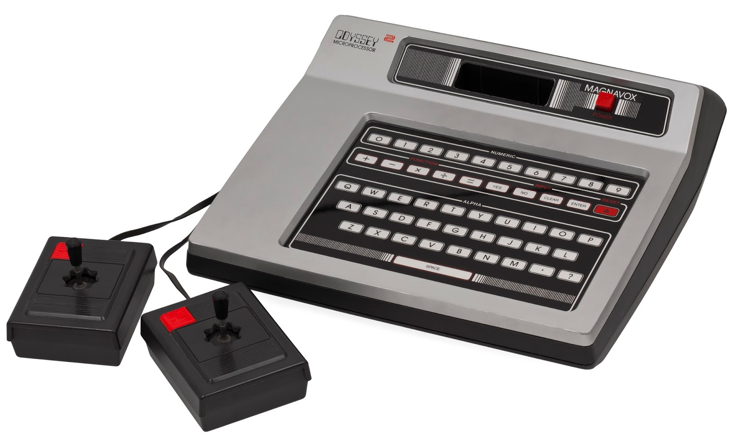

Super Nintendo / SNES (Nintendo)

The Super Nintendo was Nintendo’s foray into 16-bit gaming. Its controllers featured Start / Select buttons alongside a D-Pad and four additional game buttons labelled A, B, X and Y. This controller layout should be readily familiar to NES fans given that it just adds two extra buttons.

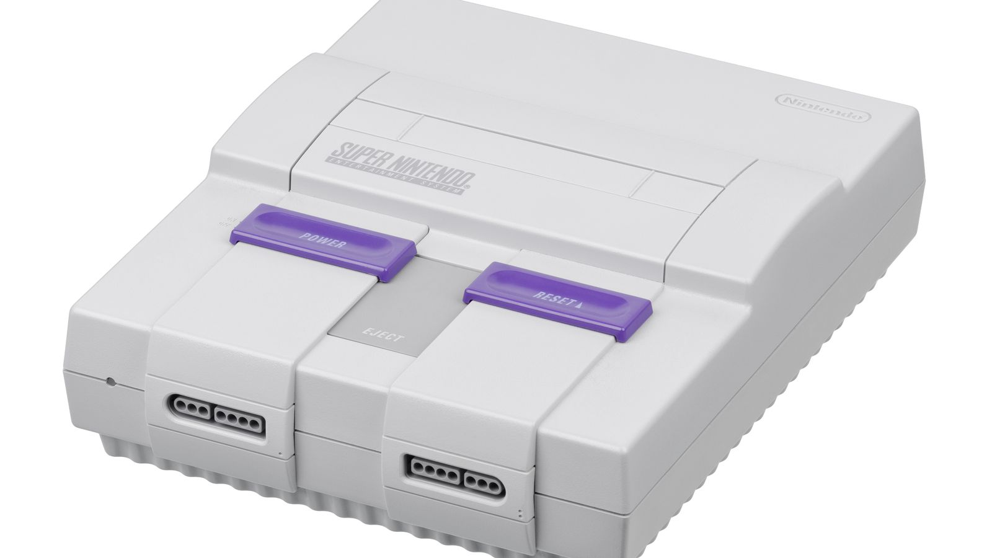

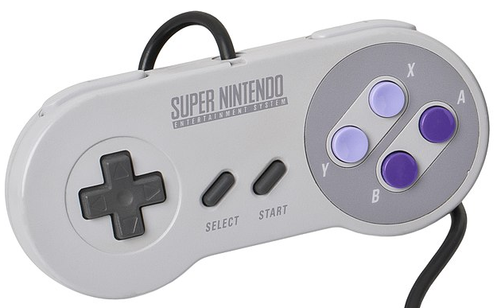

TurboGrafx-16 / PC Engine (NEC)

The NEC TurboGrafx-16 was billed as a 16-bit game console and uses flat HuCard style game cartridges that were about the size of a credit card. It also, later, had a CD-ROM add-on. The gamepad controllers featured a D-Pad, Select / Run buttons typically used for starting a game and two additional buttons marked I and II (along with switches above them to turn on rapid fire).

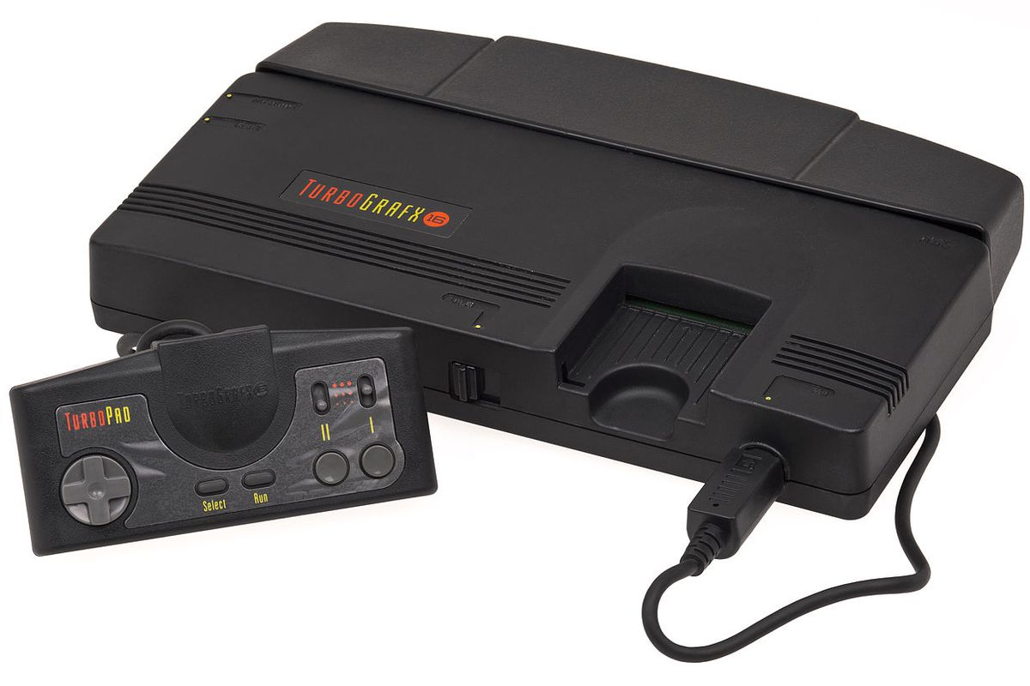

Vectrex (GCE / Milton Bradley)

The Vectrex was a standalone (i.e. no TV hookup required as the display was part of the console) vector graphics video game console and used color overlays on the screen to add to its graphical flair (pictured with the Minestorm overlay on the screen). Overlay files (.OVR), available on the same site as the main core, must be placed in the same folder as the ROM files for the Vectrex core to display them. The controller consisted of a joystick and four buttons numbered 1-4.

